# Captions in Teams

In Teams, the instructor does not need to enable live captions. All participants in a meeting have the ability to turn captions on and off themselves. Please show your students where this option can be found.

## Show live captions during a meeting

To show live captions during a Teams meeting, click on **More**in the horizontal menu bar at the top, then select **Language and Speech**, then click on **Show Live Captions**. This option is available for both the host and participants.

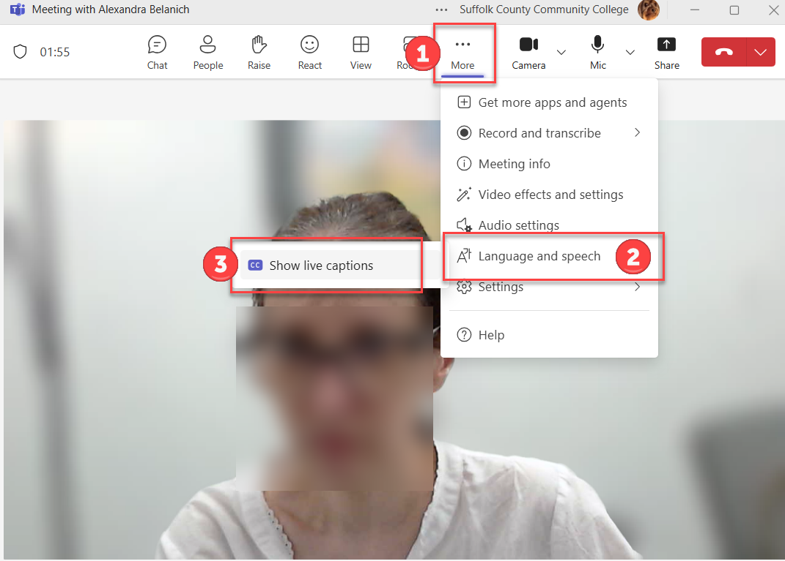

## Captions for recorded meetings

If you choose to record the meeting, captions and a transcript will automatically be generated, regardless of whether live captioning was turned on during the meeting or if **Start Transcription** was enabled. To access your recordings, go to OneDrive, then **My Files**.

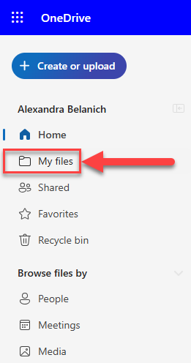

Next, look for the **Recordings**folder. The recordings will be found there. To access the captions, simply click on the **CC**icon in the video player. The captions and downloadable transcript will appear.

